Task 7 :
Dashboards and Reports: Tracking Progress and Performance - 2 hour(s)
- Creating Personal and Team Dashboards in Jira
- Useful Gadgets for Your Jira Dashboard: Filters, Charts, and More
- Sharing and Cloning Dashboards with Stakeholders and Teams
- Scrum Reports: Velocity, Burndown, and Sprint Report Explained
- Kanban Reports: Control Chart and Cumulative Flow Diagrampro

Creating Personal and Team Dashboards in Jira ::
Dashboards in Jira provide a centralized view of issues, progress, and project metrics. They can be personal or shared with teams. It helps to know what is happening right now. A dashboard is a customizable page that shows issue lists, charts and progress indicators. All updating live from jira data.
Every dashboard has components :
- Dashboard : The page
- Gadgets : Widgets on the page
- Filters : Data source
Personal Dashboards :
Personal dashboards are used by individual contributors. It shows open issues, blockers and sprint work. IT can be private and they are personal focused boards.
Hasds on :
- Click Profile → Dashboards → Create Dashboard.
- Enter a name and description.
- Select Privacy: Private or Shared with specific users/groups.
- Click Create.

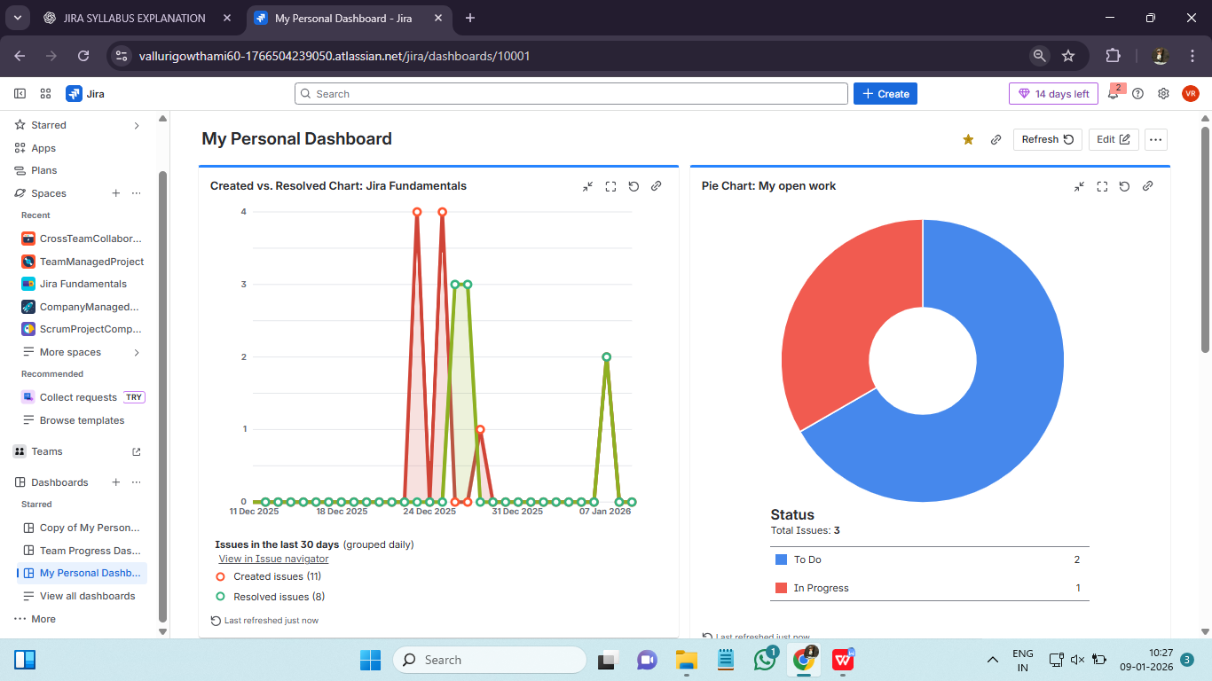
Team Dashboards :
Team dashboards are used by teams , leads and managers. It shows progress, blockers and priorities. It can have shared visibility and they are not private.
Hands on :
- Follow the same steps as creating a personal dashboard.
- In Privacy, select Share with Project or Group.
- Add team-relevant gadgets like Sprint Burndown, Project Progress, or Epic/Story Status.
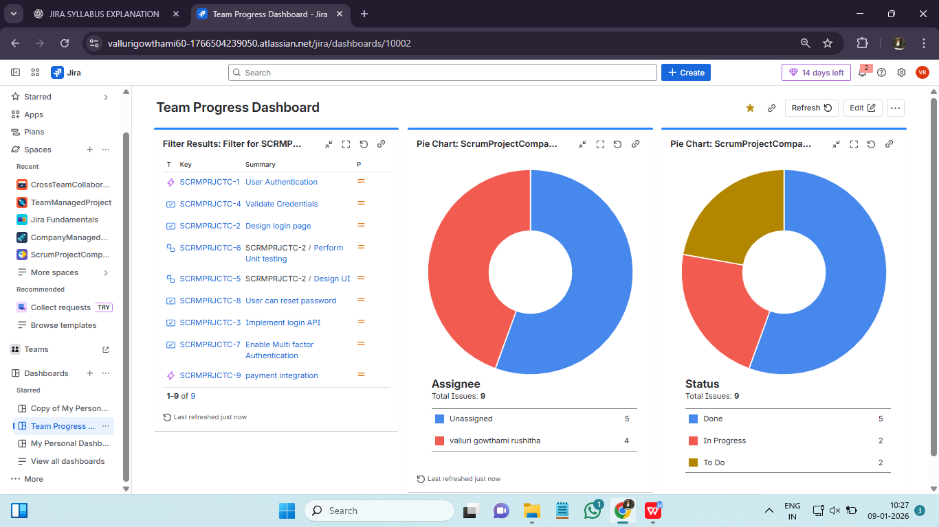

Useful Gadgets for Your Jira Dashboard ::
Jira dashboards use gadgets to display important project information visually. Gadgets help you track issues, updates automatically and uses saved input data. Filters power gadgets.
- Filter results : Shows live list of issues. A live list updates automatically.
- Pie chart : Shows distribution of issues. We can group by status, by priority, by assignee, and issue type. Used for standups, reviews and management updates.
- 2 dimensional filter statistics : Shows cross analysis in a table. (status * assignee)
- Sprint health : Shows current sprint status, completed work , remaining work, risks. It works only for scrum and used by scrum master and team leads.
- Created vs resolved chart : Shows trend over time, issues created, issues resolved. It helps to answer “Are we keeping up or fallinf behind?”
- Average age chart : Shows how long issues stays open. It is used for SLA monitoring, identifying stale work.
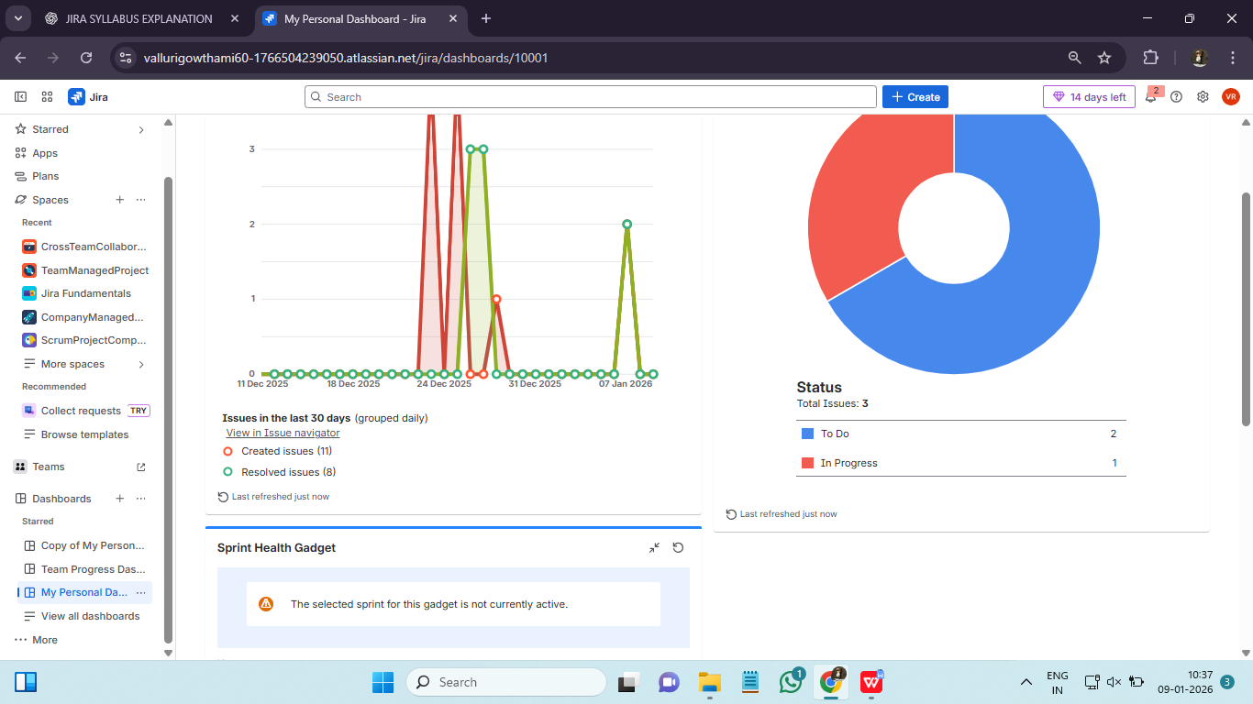

Sharing and Cloning Dashboards with Stakeholders and Teams ::
Jira dashboards can be shared or cloned to make collaboration easier and provide stakeholders with the right view of project progress. Every dashboards has 3 visibility types :
- Private : Only you
- Shared : Selected users/ groups
- Public : Many users
Dashboards are usually shared not public and by default they are private.

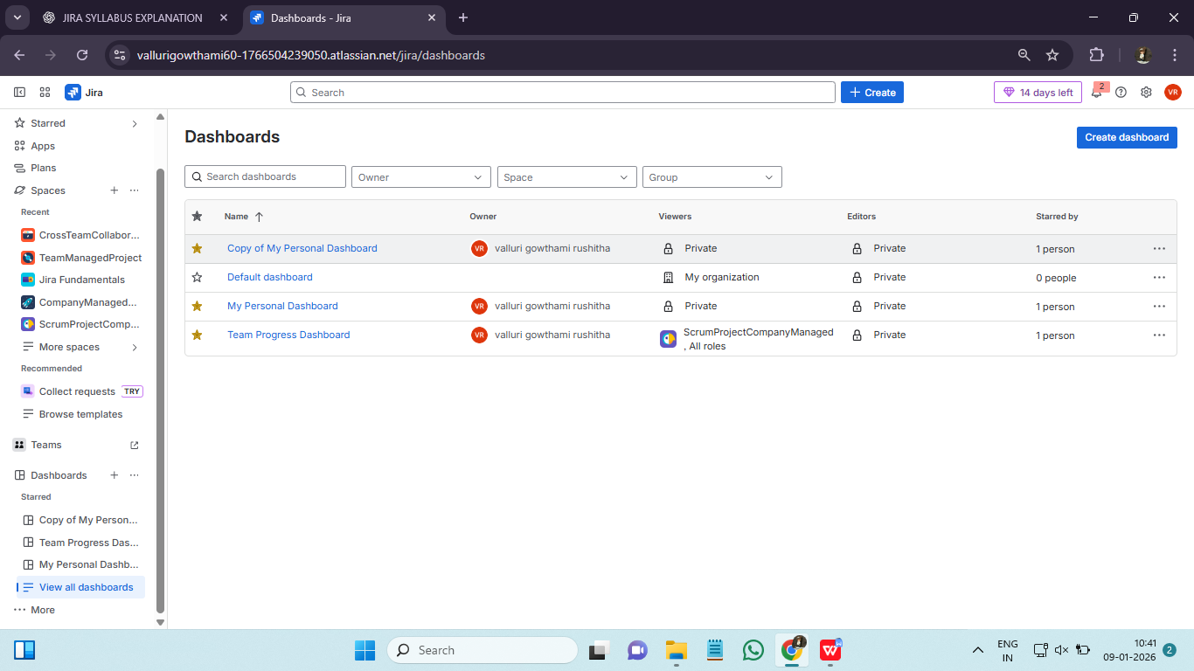

Scrum Reports: Velocity, Burndown, and Sprint Report Explained ::
Scrum reports in Jira help Agile teams track progress, plan work, and review performance during sprints. Scrum reports are built in analytics that use sprint data, measure team performances and support planning and improvement. Here are the key reports:
- Velocity Chart : Velocity is the amout of work a team actually completes per sprint. It is measured in story points. Velocity is observed as
X axis : Sprints
Y axis : Story points
It uses 2 bars as committed and completed bars.
- Burndown Chart : It shows remaining work vs time during sprint. It uses 2 lines in chart as ideal line and progress line. It is used for daily standups, early risk detection and sprint health monitoring. It is observed as :
X axis : Days in sprint
Y axis : Remaining work
- Sprint Report : A summary of what happened in a sprint in displyed. It shows committed, completed, not completed issues and scope changes. It is the best report for retrospectives, process improvement and stakehilder reviews.

Velocity chart :
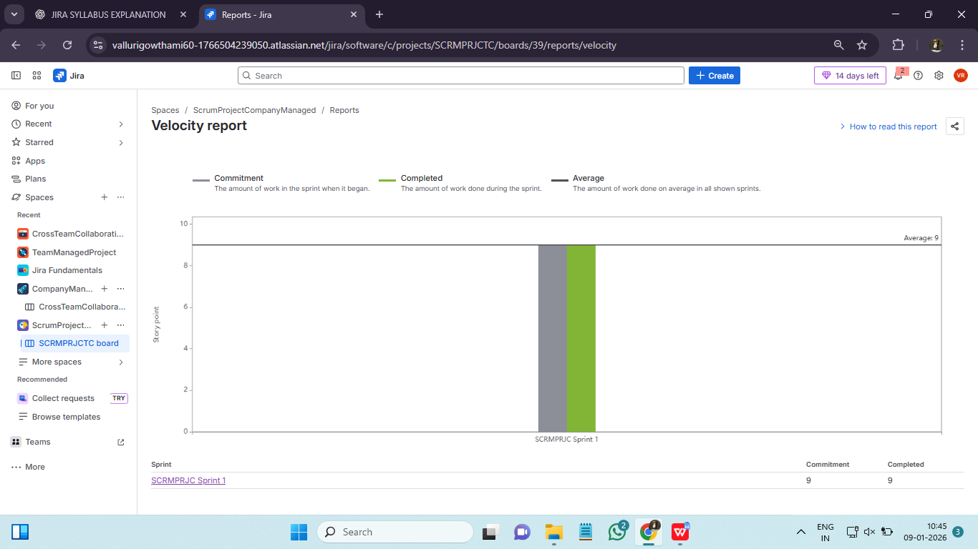
Burndown chart :
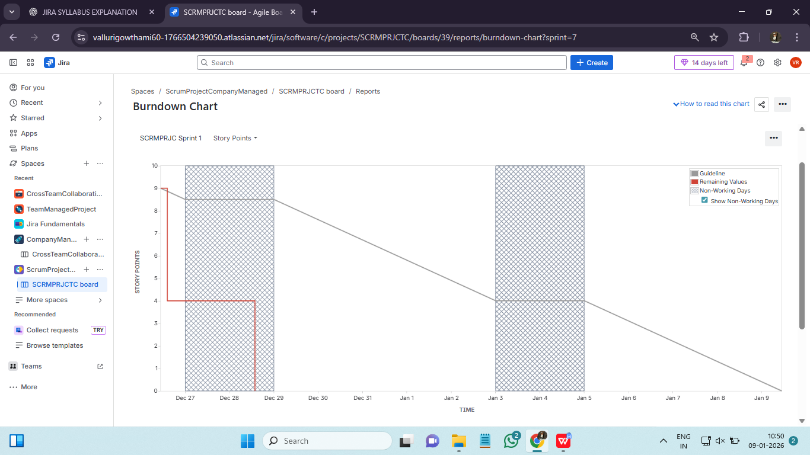

Kanban Reports: Control Chart and Cumulative Flow Diagram ::
Kanban reports in Jira help teams monitor workflow, spot bottlenecks, and improve efficiency. Kanaban reports analyze flow over time. It doesn’t need sprints. Two important Kanban reports are:
- Control Chart :
It shows how long issues take to complete. We can measure cycle time, lead time and throughput. Kanban mostly uses cycle time. It is used to predict delivery dates, set realistic SLAs, identify slow items, improve consistency.
Control charts are mainly available majorly in company managed projects and restricted in team managed projects.
- Cycle time: Time from inprogress to done.
- Lead time: Time from request to completion.
- Throughput: Numer of issues completed per time period.
2. Cumulative Flow Diagram (CFD) :
Cumulative Flow Diagram is one of the most important kanban reports. It helps team to identify flow over time, identify bottlenecks and improve predictability. CFD is a visual report that shows how many issues are in each status and how that number changes over time.
Each color=status.
X axis : Time (days/weeks)
Y axis : Number of issues
CFD Rules :
- Top line slope:
Steep upward = work finishing fast
Flat= nothing getting done
- Thickness of a band:
Thick band=Work piling up
Thin band=Smooth flow
- Parallel bands :
Parallel=Stable process
Expanding band=Bottleneck
CFD also uses metrics like cycle time, lead time and throughput.
